**9**` 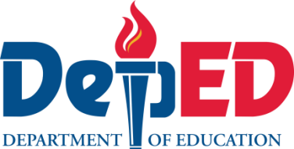

Homeroom Guidance

**Quarter 1 – Module 3: The 3Rs**

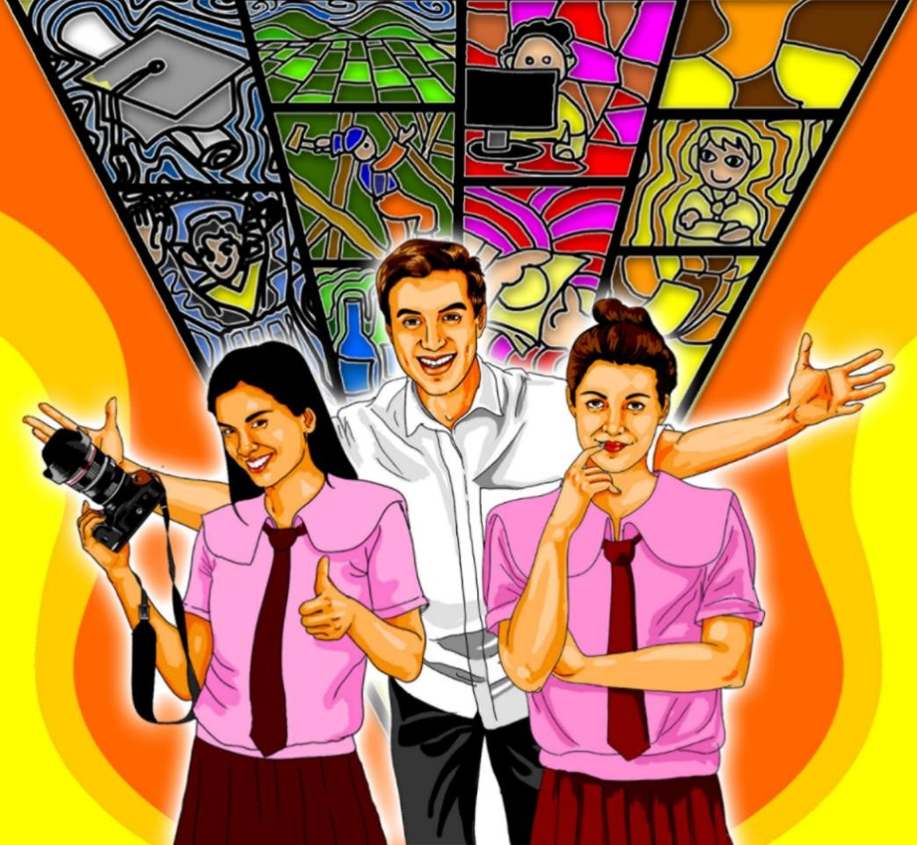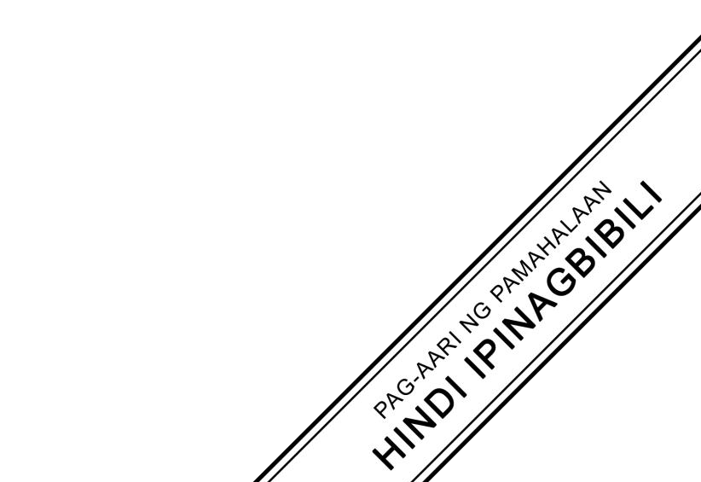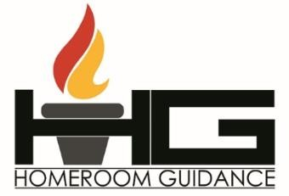

**Name:** Paul Gerald D. Pare

**Section:** 9 - Adenine

**Homeroom Guidance Self-learning Module – Grade 9**

Quarter 1 Module 3: The 3Rs

2020 Edition

**The Intellectual Property Code of the Philippines** states that “No copyright shall subsist in any work of the Government of the Philippines. However, prior approval of the government agency or office wherein the work is created shall be necessary for exploitation of such work for profit. Such agency or office may, among other things, impose as a condition the payment of royalties.”

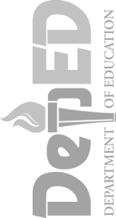Borrowed materials (e.g., texts, illustrations, musical notations, photos, and other copyrightable, patentable contents) included in this learning resource are owned by their respective copyright and intellectual property right holders. Where applicable, DepEd has sought permission from these owners specifically for the development and printing of this learning resource. As such, using these materials in any form other than agreed framework requires another permission and/or licensing.

No part of this material, including its original and borrowed contents, may be reproduced in any form without written permission from the Department of Education.

**Recommended Entry for Citation Purposes:**

Department of Education. *Homeroom Guidance Grade 9 Self-learning Module 3: The 3Rs.* Manila: Department of Education Central Office, 2020.

Published by the Department of Education Secretary: Leonor Magtolis Briones Undersecretary: Diosdado M. San Antonio Assistant Secretary: Alma Ruby C. Torio

**Development Team**

**Writers:** Julienne Rose Penaranda-Saballa, Madel R. Mabanes

**Grade Level Coordinator:** Melanie O. Mandin

**Editors:** Mark Anthony Bercando, Jona Kristen Valdez, Melynda Andres

**Illustrators:** Jayson R. Gaduena, Jerichko Bauer L. Laroco, Marieto Cleben V. Lozada, Mark Dave M. Vendiola, Katrina S. Padilla, Grace Ann A. Caldito, and Cherry Amor R. Laroza

**Layout Artists:** Jacqueline E. Libut and Cherry Amor R. Laroza

**Management Team:**

* Bureau of Curriculum Development: Jocelyn DR. Andaya, *Director IV,* Ma. Isabel Victorino, *CSDD Chief*, Mark Anthony Bercando, *Supervising EPS,* Jona Kristen Valdez, Senior EPS, Melynda Andres, Senior EPS
* Bureau of Learning Resources

**Homeroom Guidance Grade 9 Quarter 1 – Module 3:**

**The 3Rs**

**Gabay sa Magulang/Tagapag-alaga**

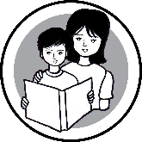

Nagdulot ng napakaraming pagbabago sa pamumuhay ng bawat Pilipino ang pandemyang nararanasan ng buong mundo. Sa gitna nito, kaisa ng Department of Education ang inyong tahanan upang maipagpatuloy ang edukasyon ng lahat ng mag-aaral sa buong Pilipinas. Dalawa sa mga pamamaraang ito ang paghahanda ng Learning Continuity Plan at ng Most Essential Learning Competencies (MELCs).

Sa taong ito, inihanda ang Homeroom Guidance MELCs na naglalayong matulungan ang mag-aaral upang maipagpatuloy ang pagkatuto sa kabila ng mga pagbabagong dulot ng pandemya. Naglalayong maituro ng Homeroom Guidance (HG) ang mga kasanayan sa buhay o life skills sa pamamagitan ng self-learning modules. Nakatuon ito sa tatlong mahahalagang domeyn – ang *academic, personal/social* at *career development*. Binigyang-pokus sa Homeroom Guidance MELCs ang mga gawaing makatutulong sa lahat ng mga mag-aaral na magkaroon ng Rasyunal na Pag-iisip (Rational Thinking), Malusog/Maayos na Pagkilos (Healthy Behavior) at Positibong Disposisyon (Positive Disposition) na higit na kailangan sa panahong ito.

Malaki ang gagampanin ng mga magulang upang mapagtagumpayan ang mga gawaing nakalatag dito. Kakailanganin ng mag-aaral ang inyong patnubay at gabay. Kung kaya, hinihingi ng DepEd ang inyong suporta na makatutulong upang mapagtagumpayan ng mag-aaral ang mga hamon sa buhay, maisakatuparan ang mga inaasahang gawain at higit sa lahat, matutunan ang mga kasanayan sa buhay na kailangan nilang taglayin sa yugtong ito.

## Introductory Message

For the learner:

As part of examining your life as you go along this new normal, it is important to know your rights, roles and responsibilites. Knowing your rights and roles will also lead to appreciation of your responsibilities and contribution in this world.

This module is composed of different tasks as a reflection of how you handle the demands of life. This can help you understand the things that are happening around you. Moreover, it can help you to stay effective in dealing with different challenges.

Work on the tasks seriously; seek help if you believe you need to. Remember, in life there are things that you cannot control. There will be negative events that will challenge your positive dispositions. However, do not be disheartened: you have the means on how to overcome it – you have that in you! Embark on this journey of overcoming your weaknesses and optimizing your strengths to attain your better version.

This self-learning module has six intercatives tasks, which are as follows:

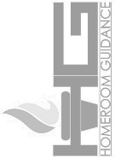 **Let’s Try This** – which will help you to get ready to learn;

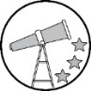**Let’s Explore This** – which will guide you towards what you need to learn;

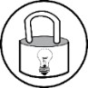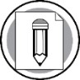**Keep in Mind** – which will give you the lessons that you need to learn and understand;

**You Can Do It** – which will help you apply the lessons learned in daily activities;

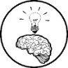 **What I Have learned** – which will test and evaluate your learning; and **Share Your Thoughts and Feelings** – which will help you express your thoughts, opinions and feelings.

Make sure to read, think, follow, and enjoy every task that you are asked to do.

Have fun! Stay safe and healthy!

|  |  |
| --- | --- |
| **MODULE**  **3** | **THE 3RS** |

## Learning Objectives

At the end of this module, you are expected to:

1. explain the child’s rights and the roles and responsibilities as a member of the family and community;
2. demonstrate accountabilities and responsibilities in the practice of Child’s rights; and
3. appreciate the relationship between child’s rights and responsibilities.

**Period**: *Week 3 of 1st Quarter*

**Suggested Total Time Allotment**: *60 Minutes*

## Materials Needed:

* *Clean sheets of paper/bond papers*
* *Coloring materials (if available)*

# Introduction

This module will try to make you aware of your importance as a member of your family and the community. Likewise, this will redirect you to your functional knowledge on child’s rights, roles and responsibilities that can help to become a better contributing individual especially in this time of pandemic.

Being part of the community, you have to know your roles and rights so that you can perform your responsibilities well. Every right that you enjoy is coupled with a responsibility that you need to face.

Get to appreciate how to be more productive member to your family and to the community at the end of the module.

# Artboard 1@5xLet’s Review

***Suggested Time Allotment: 1 minute***

Module 2 helped you identify the different challenges on your home and school activities and the ways to manage them positively. The module also led you to compare the pros and cons of the different study habits you have employed. Furthermore, it gave you the opportunity to share your insights on performing your daily tasks in life.

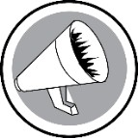 **Let’s Try This**

Suggested Time Allotment: 5 minutes

# Roles or Responsibilities

## Procedure:

1. Copy the images below on a clean whole sheet of short bond paper.
2. Pick up the words in the box and categorize whether they are “roles” or “responsibilities”.
3. Place the words on the petals of the right flower.
4. Answer the processing questions that follow.

Proper and frequent hand washing

Take care of my siblings

Study well

Wear a face mask

Sanitize objects or items

Observe physical

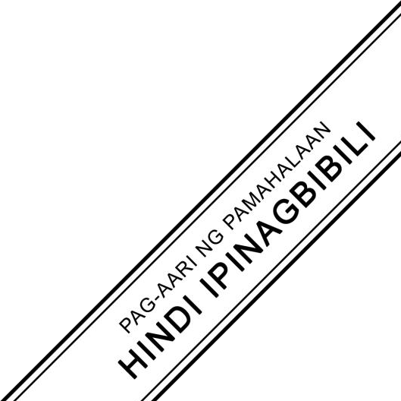

Child

Proper and frequent hand washing Take care of my siblings

Observe physical distancing

Grandchild

Sibling Study well

Parents

Sanitize objects or items

Wear a face mask

Student

Child

Grandchild

Parents

Sibling

Student

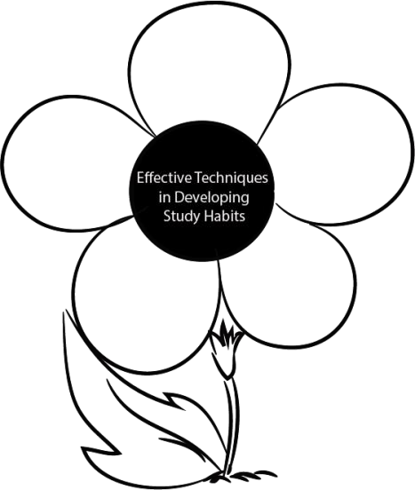

roles



responsi bilities

Processing Questions:

* 1. What roles and responsibilities in the choices are the most relevant to you? Why? The roles that are most relevant to me are as a student, is being a student, child, sibling. My responsibilities are wearing a face masks, taking care of my siblings, observing social distancing, proper and frequent hand washing, study well, and sanitize objects or items.
  2. 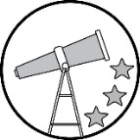How do you describe the way you perform your roles and responsibilities? Cite a current experience where these things are evident.

I need to study well at this current pandemic because the modules given to us are too many to handle and can’t just be finished within a week.

# Let’s Explore This

**Suggested Time Allotment:** 10 minutes

# Responsibly Right

Below are the four main baskets of children’s rights and the different examples of the several child rights. For each of the four main baskets, categorize and identify among the given examples of child rights. Cite examples to each right that you have experienced. Write this on a clean sheet of bond paper. Then, answer the processing questions that follow.

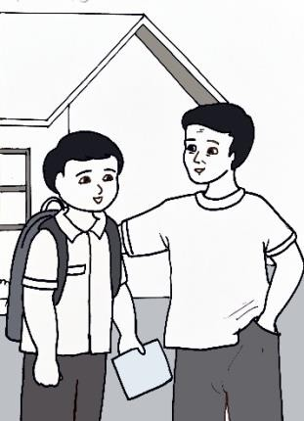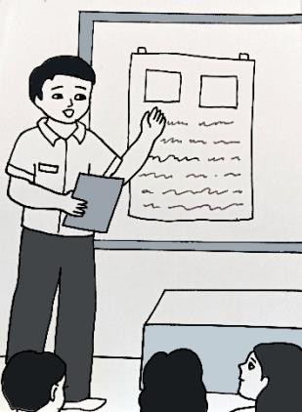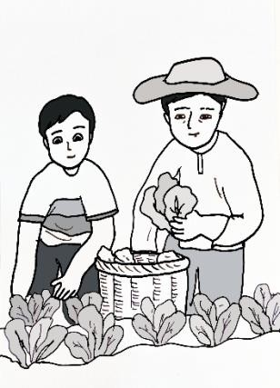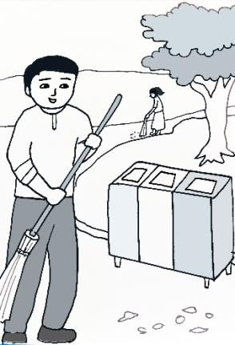

Four Main Baskets of Children’s Rights

Right to Development

Right to Survival

Right to Protection

Right to Participation





|  |  |  |  |  |
| --- | --- | --- | --- | --- |
|  | **RIGHTS OF A CHILD**  Right to be born well  Right to live a full life  Right to legally registered name and nationality  Right to express their views and opinions  Right to think and believe what they want and to practice their religion  Right to get and share information, as long as the information is not damaging to them or others  Right to relax, play and to join in a wide range of leisure activities  Right to special care and support for children with any kind of disability so that they can live a full and independent life  Right to good quality health care, clean water, nutritious food and clean environment  Right to education | | |  |
|  | Right to protection from any harm |  |

## Right to Participation:

## Right to legally registered name and nationality

## Right to express their views and opinions

## Right to special care and support for children with any kind of disability so that they can live a full and independent life.

## Right to Protection:

## Right to think and believe what they want and to practice their religion

## Right to protection from any harm

## Right to Survival:

## Right to be born well.

## Right to live a full life

## Right to good quality healthcare, clean water, nutritious food and clean environment.

## Right to relax, play and join in a wide range of leisure activities.

## Right to Development:

## Right to education

## Processing Questions

1. What are the child’s rights that you think you enjoy most? I enjoy the right to good quality healthcare, clean water, nutitious food and clean environment.
2. What are the other child’s rights that you hope to experience more? And how? I really want to experience the right to relax, play and join in a wide range of leisure activities. This is because I didn’t play or procrastinate more often due to school homeworks and projects. Some other important things as well. Recently, I learned how to focus better and many more things about self-improvement. I need to have 2 habits completed per month.

# Keep in Mind

**Suggested Time Allotment**: 10 minutes

Though you already had taken up child’s rights in your previous grade levels and lessons, let’s try to revisit The Rights of a Filipino Child which is under the Presidential Decree No. 603 or the *Child and Youth Welfare Code*. It states that the child is one of the most important assets of the nation. Likewise, the UNICEF Convention on the Rights of the Children has also identified the following child rights:

1. Every child has the right to life, survival and development.
2. Every child has the right to name and nationality.
3. Every child has the right to keeping families together.
4. Every child has the right to be educated.
5. Every child has the right to play and enjoy whenever they have the opportunity.
6. Every child has the right to be protected from abuse of adults.
7. Every child has the right to live peacefully away from bad influences.
8. Every child has the right to be cared whenever their parents are not available or cannot sustain their needs.
9. Every child has the right to express their views and opinions and to their privacy.
10. Every child has the right to grow up peacefully and getting what they want for the good of their lives.

All child rights are human rights, which were especially created for children’s protection and for them to become better individuals. According to UNICEF Committee on the Rights of the Child, there are 4 main areas or “baskets” (groups) of Children’s Rights; these are the *right to protection* from discrimination, abuse, neglect, exploitation, torture; the *right to survival*, comprising the elements of life, nutrition, water, health, air; the *right to participation*, including expression of views, decision- making, access to information, freedom of association; and *right to development* which includes education, standard of living, adequate for the child’s physical, mental, spiritual, moral and social development.

Aside from rights, children also have roles such as being a son or daughter, sibling, grandchild, student and a person among others. The roles of children nowadays are also no longer based on sex since we are now embracing gender equity, wherein a girl can do the tasks previously intended for a boy, and vice versa. Both sexes can do home repairs, laundry, cooking, sewing and many more.

Children have rights and roles. However, there are also responsibilities that go along with them. These make up the three Rs of a child.

Based on the *Child and Youth Welfare Code,* the following are the identified responsibilities of a child:

1. Strive to lead an upright and virtuous life in accordance to one’s religion, the teachings of his elders and mentors, and his clean conscience;
2. Love, respect, and obey his parents, and cooperate with them in the strengthening of the family; this includes following the health and safety protocols in this time of pandemic such as observing physical distancing, frequent handwashing, wearing of face masks and face shields, sanitize objects and items, and consult medical attention when there are symptoms.
3. Extend to his brothers and sisters his love, thoughtfulness, and helpfulness, and endeavor with them to keep the family harmonious and united;
4. Exert his utmost to develop his potentialities for service, particularly by undergoing a formal education suited to his abilities, in order that he may become an asset to himself and the society; This includes studying well for your future.
5. Respect not only his elders but also the customs and traditions of people, the memory of heroes, the authorities, the laws of our country and the principles and institutions of democracy;
6. Participate actively in civic affairs and in the promotion of the general welfare.
7. Help in the observance of individual human rights.

Your three Rs will make you appreciate yourself better. Know your basic *rights*; perform your *roles* well; and act on your *responsibilities*. Your three Rs will make you a vital part of the community.

# You Can Do It

## My Rights and Responsibilities Action Plan Suggested Time Allotment: 10 minutes

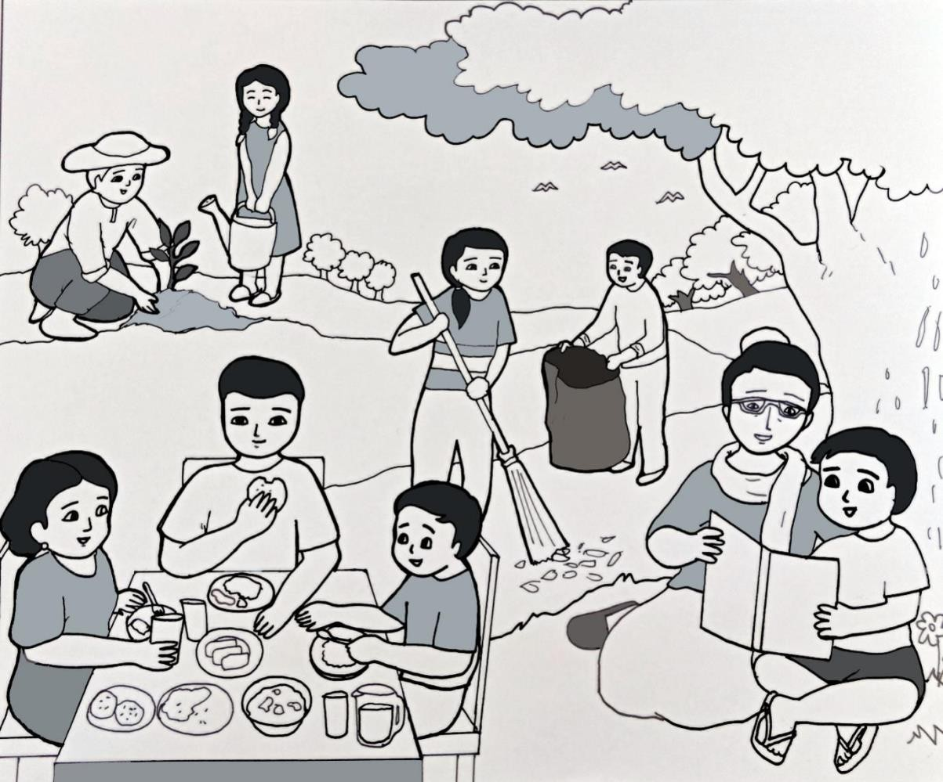

Now, to assess if you really understand your rights, you are going to make an action plan on how you are going to exercise these rights as a child, which will help you to become responsible for yourself, your home and your community.

Copy this activity on a clean sheet of paper or one short bond paper and fill out the blank spaces. An example has been given.



Donate stuff that we weren’t using anymore to poor.

Tell them to not forget to brush their teeth and other hygienes

Right to good quality healthcare, clean water, nutritious food and clean environment.

Take advantage of them and use it everyday.

Warned to stay 1m away from other people and other do’s during pandemic

Protect my younger siblings against others that might bully him/her.

Avoid engaging to any fight

Right to protect

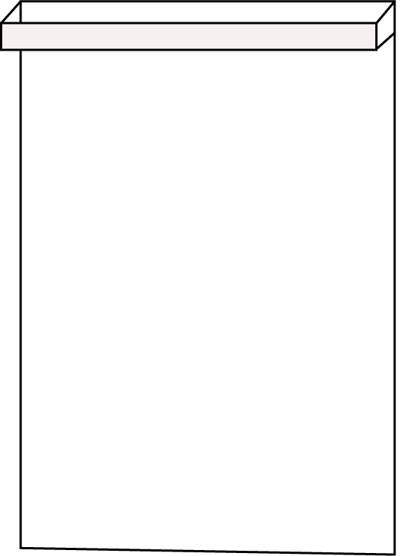

***My Rights and My Responsibilities Action Plan***

***THINGS TO DO***

*Child’s Rights*

*Self*

*Home*

*Community*

Right to be educated

Share knowledge on HEALTHY PROTOCOLS

during this COVID19

pandemic.

Assist siblings or any family member in their academic endeavors

Apply Effective Study Habits

# What I have learned

**Suggested Time Allotment**: 10 minutes

On a clean sheet of bond paper, answer the following questions.

1. What is the role that you are still trying to fulfill as of the moment? Right to relax, because I can’t procrastinate longer than 2 hours everyday due to school works.
2. What suggestions or tips would you give to yourself to do it? Do more habits per month to better improve myself.
3. How do you promote child’s rights in school, at home and community? Give at least 5 ways.

* Making poster that advocates in these things
* Make an advocacy about the rights and post them in social media.
* Sending messages to various private messages and group chats.
* Telling these rights to my family.
* Approach my classmates and share them about the rights of a child.

# Share your Thoughts & Feelings

**Suggested Time Allotment**: 10 minutes

* 1. Choose a song or poem about taking responsibilities or fulfilling a role. Write on a piece of paper the part/s that you want to reflect on. Share how the song/poem resonates with your current status as a child.

This poem was printed on a calendar for 2002, displayed in the United Nations Building in New York.

There shall be peace on earth, but not until

All children daily eat their fill,

Go warmly clad against the winter wind

And learn their lessons with a tranquil mind.

And then, released from hunger, fear and need

Regardless of their color, race or creed

Look upward smiling to their skies,

Their faith in life reflected in their eyes.

This poems shows us about fulfilling the right to a good quality life. It also promotes environmentalism therefore engaging us to take care of our environment.

## ====================

**References**

Makati Medical Center. *The 12 Rights of Filipino Children*. Published October 30, 2019. https:[//w](http://www.makatimed.net.ph/news-and-exhibits/news/celebrating-national-childrens-)ww[.makatimed.net.ph/news-and-exhibits/news/celebrating-national-childrens-](http://www.makatimed.net.ph/news-and-exhibits/news/celebrating-national-childrens-) month.

Presidential Decree No. 603, or *The Child and Youth Welfare Code*

UNICEF. *How the Convention Works.* The United Nations Convention on the Rights of the Child. https:[//w](http://www.unicef.org/media/60981/file/convention-rights-child-text-child-friendly-)ww[.unicef.org/media/60981/file/convention-rights-child-text-child-friendly-](http://www.unicef.org/media/60981/file/convention-rights-child-text-child-friendly-) version.pdf

UNICEF Private Fundraising and Partnerships Division. *Child Rights Toolkit: Rooting Child Rights in Early Education, Primary and Secondary Schools.* First Edition. UNICEF: Geneva, 2014.

## ====================

**For inquiries or feedback, please write or call:**

Department of Education - Bureau of Learning Resources (DepEd-BLR) Ground Floor, Bonifacio Bldg., DepEd Complex

Meralco Avenue, Pasig City, Philippines 1600 Telefax: (632) 8634-1072; 8634-1054; 8631-4985

Email Address: [blr.lrqad@deped.gov.ph](mailto:blr.lrqad@deped.gov.ph) * [blr.lrpd@deped.gov.ph](mailto:blr.lrpd@deped.gov.ph)